**LAB**

**OF**

**_____________________________**

**SUBMITTED BY**

**_____________________________**

**ROLL NO #**

**_____________________________**



**SUBMITTED TO**

**_____________________________**

**DEPARTMENT OF ________________________________**

**SIR SYED UNIVERSITY OF ENGINEERING &**

**TECHNOLOGY**

**LAB**

1. Create a new table Person and insert at least 5 records.

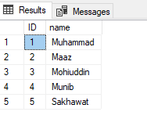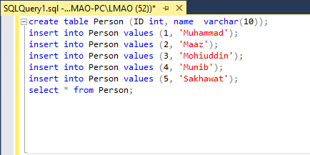

1. Add a new field in the Person table.
2. Modify any field in the Person table.

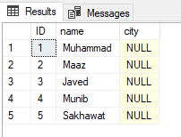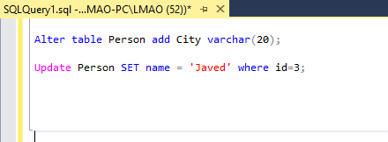

1. Create a new table Customer and insert at least 5 records.

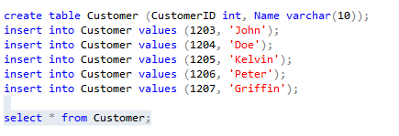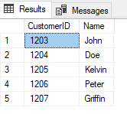s

1. Create a new table Order and insert at least 5 records

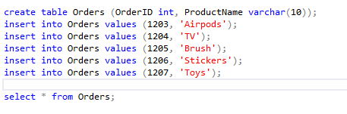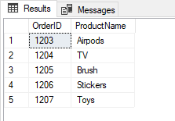

1. Use some constraints in your queries

